**Chapter – 1**

**Project Introduction**

* 1. **Introduction**

The Project is developed with the objective to seek citizen’s attention towards making a better, safer and more responsible society .In this system any citizen of India can register or file any complaint anytime without facing any trembling, uneasiness or doubt concern.

**Citi-Cops** is developed for the citizens to interact with police department indirectly. It is also made to spread awareness to the citizens to raise their voices and take stands for themselves as well as their countrymen which gradually will lead to more secure ,safer and out of harm’s way society.

It helps the public to report about the crimes to the cops/police without any anxiety in correct time which leads to the betterment of the police department and also helps in solving the cases.

The other facilities such as E-locker, Contact to Cops, SOS will be helpful at the time of emergency and necessity.

* 1. **Goals:**
* Any complaints irrespective of its type, details, location will be managed by the respective stations and their heads and department.
  + - * Providing an effective and most efficient environment/interface to the citizens to interact with police department with ease and efficacy.
      * Better perspective and easy to use.
      * Availability of data to Police heads and department for quick decision making and analysis of the crime and their types.
      * Providing each station a unique id respective of its location and managing the reports, complaints and other issues of the suffered ones.

**1.3 Aim:**

The aim of embracing this project is to develop Citi-Cops reporting and management system which is easily accessible to the citizens, police department and the administrative department .This web portal gives easy accessibility to the user to file any complaint without getting worried of time, anxiety and various questionnaires from Cops. As per the requirements, modification can be practiced to introduce some new events, new features and modules anytime.

**1.4 Objectives:**

Citi-Cops accomplishes all the aims which was aforesaid and provide its end-user to avail all the facilities well said as services provided by Police department to the citizens which leads to more reliable and strengthen society.

To avail the services and access the information and facilities, it is obligatory for the applicant and Cops to register first so that they can login with their unique ids unlike Cops who’s Ids and passwords are provided by Admin as per their station location.

By using the applicant-credentials, the end-user would be free to avail all the facilities specifically E-Locker, Contact to Cops, SOS. Citi-Cops provide flexibility to Admin to update, modify and include any new station anytime with the easy access.

The major focus of implementing Citi-Cops is to computerize the activities of controlling crimes, administration and support services across the state in an integrated fashion so as to enable the division heads and Cops head to obtain the relevant information.

Besides it is also envisaged to reduce dependence on paper and also help in automatic maintenance of registers and generation of reports, data analysis, better planning and coordination, speedy detection of crimes and monitoring the prosecutions.

**1.5 Scenario:**

Apparently it is bit arduous somewhere terrifying and quite frightening to the public to interact with the police department and share the suffering encounters and concealed experience especially for women. Some illegal activities or suspicious surrounding also makes us uneasy which gradually leads to the fearsome and irresponsible society .Most of the crimes don’t reach to the Police due to lack of time, or anxiety and Ignorance.

This project will be overcoming all these factors and will also assist and lend a helping hand to the Police department to know the surrounding’s atmosphere and also crime rates and actuality of the society and their troubles.

**1.6 Critical Success Factors:**

* Easily operated, handy and adaptable to every Citizen irrespective of their qualification and age.
* Providing relevant, more convenient, precise and righteous information.
* Better interfaces, easy accessibility of complaints and services from ends, user as well as Cops (Station).
* To spread awareness and helping citizens to form a better, peaceful, secure and well-disposed.

**1.7 Existing System:**

Some existing system is just developed as Beta launch product and not fulfilling the following activities.

* Only limited number of Applicant/users can access the web portal.
* Lack of Security and ease of access.
* Some system doesn’t provide online Complaints specially F.I.R, Lost Vehicle and Anonymous Complaint for illegal/suspicious activities.
* Some system doesn’t maintain and manage the Cops credentials and information.
* Some existing system doesn’t concern with the Location wise or city wise or Station wise information of the complaints and crime.
* They don’t provide other services like E-Locker, SOS or Contact to cops area wise.

**1.8 Proposed System:**

* An Online Solution and Paper-less system is thoughtful, profitable as the solution is inherently distributive and more practical approach to lessen crimes and making people aware about their rights as well as duties.
* Since the Proposed System is modifiable and updatable anyone can add or include some extra feature into it with the little modification in source code.
* The distributive characteristic of the online solution helps in getting the different police stations to share information and get in contact with one another which will lead to better functioning of Police department and also helps in diminishing and lessening crime rates.

**Chapter – 2**

**Project Analysis**

**2.1 BUSINESS RULE**

A business rule is “a statement that defines or constraints some aspect of the business. It is intended to assert structure or to control or influence the behaviour of the Business.” Most organisations have a host of rules and/or policies that impact its database. But there are also some business rules that cannot be represented in Common data modelling notation. Those rules that cannot represent in a variation of entity – relationship diagram are stated in natural language and some can represented in the relational data model.

**2.2 Data Flow Diagram (DFD)**

A data flow diagram (DFD) is a graphical representation of the “flow” of data that can be used to represent a system in terms of the input data to the system, various processing carried out on these data, and the output data generated by the system.

**2.2.1 Context Diagram (Level 0):**

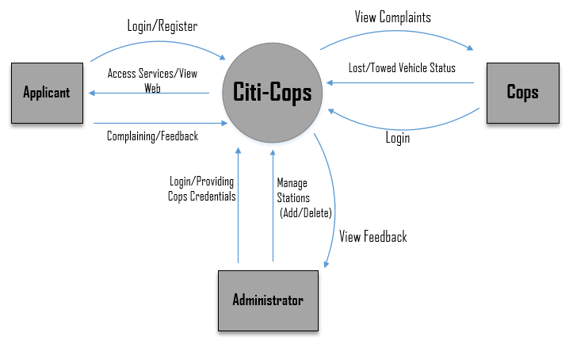

Fig 1:Context Diagram

**2.2.2 LEVEL 1:**

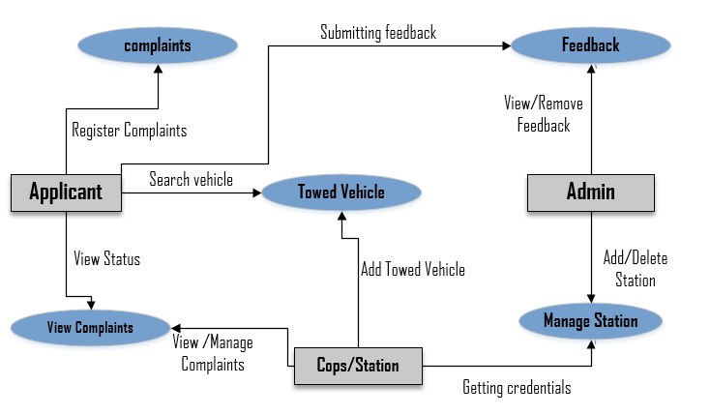

Fig 2: level 1 diagram

**2.2.3 LEVEL 2:**

**2.2.3.1 For Cops and Applicant Login:**

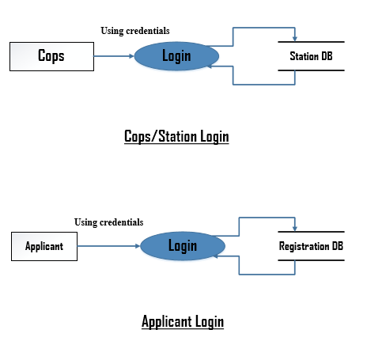

Fig 3: level 2 diagram for cops and application

**2.2.3.2 For Stations:**

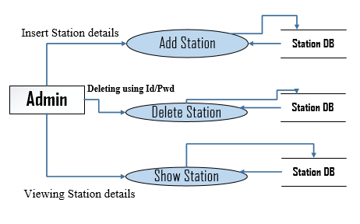

Fig 4: level 2 diagram for stations

**2.2.3.3 For Applicant Services :**

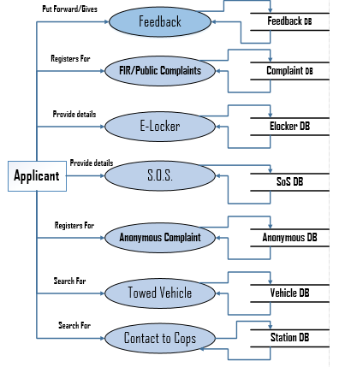

Fig 5:level 2 diagram for applicant services

**2.2.3.4 For maintain and view complaint:**

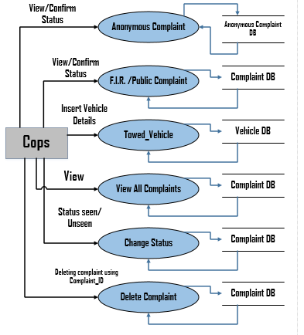

Fig 6:level 2 diagram for maintain and view

**2.3 Entity-Relationship Diagram (E-R Diagram):**

An entity relationship diagram (ERD) shows the relationships of entity sets stored in a database. An entity in this context is a component of data. In other words, ER diagrams illustrate the logical structure of databases.

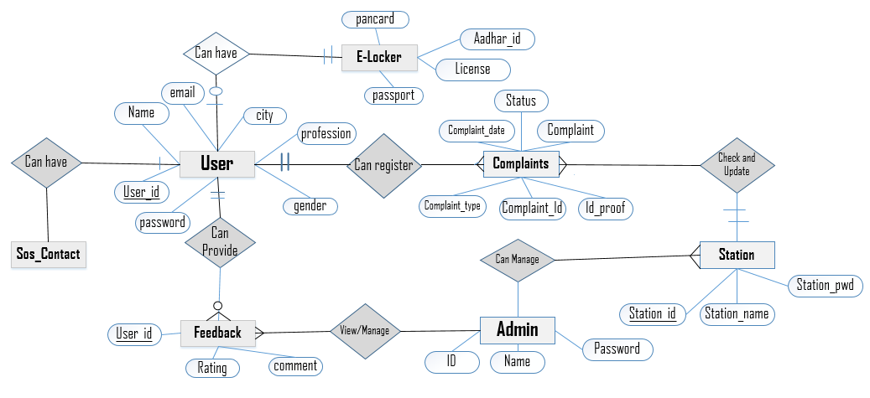

Figure 7 : E-R Diagram for the **Citi-Cops .**

**2.4 Use-Case Diagram:**

Use case diagrams are used to gather the requirements of a system including internal and external influences. These requirements are mostly design requirements. Hence, when a system is analysed to gather its functionalities, use cases are prepared and actors are identified. Use case diagrams are considered for high level requirement analysis of a system. When the requirements of a system are analysed, the functionalities are captured in use cases.

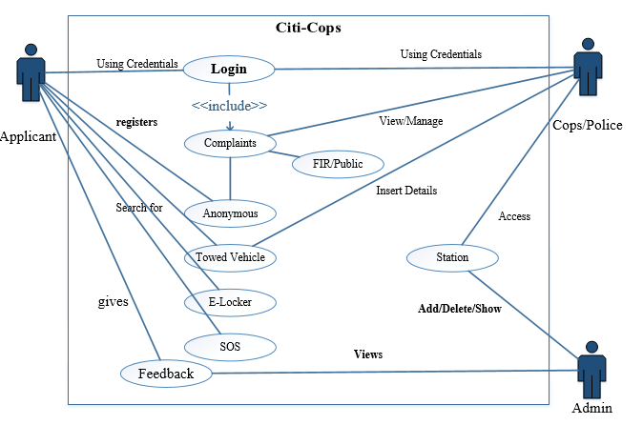

Fig 8 : Use-Case Diagram for **Citi-Cops**

**2.5 Input/output Requirements**

**Input Requirements:**

After discussing and getting information and requirements regarding our project we encountered following input requirements.

* The basic information provided by Applicant/user to the Citi-Cops which is further functioned and used as the part of complaint process.
* The User interface must be uncomplicated and practicable so that it can lead to easy use of accessing and one can easily register through the web.
* The Operations should take place transparently.
* Victim details.
* Crime details.

**Output Requirements:**

* Comprehensive Details about each complaint whether it’s FIR, Anonymous or Public and respective suffered ones and applicant with date and location.
* List of all Police station location and their details including Head position, Head name and their contact number.
* List of all Applicants’ feedback with website’s rating.
* Crime rates and Society’s view and perspective related to issues and surroundings.

**2.6 Operating Requirements**

**Hardware** **Requirement:**

* Intel Processor 2.0 GHz or above.
* Minimum 256 MB of RAM or more.
* 10GB or more Hard Disk Drive or above for efficient and proper functionality
* Other Standard Components.

**Software** **Requirement:**

* Any windows 2000 SE or above versions.
* Java, JDBC & JSP.
* Eclipse Luna and JVM.
* MySQL, Sqlyog.
* Any aforementioned technology compatible browser to run the application or to Test it.

**System Configuration:**

To develop and to implement we acquired system with the following configuration:

* 4GB of RAM.
* 1TB of Hard disk.
* Intel(R) Core(TM) i5-4210U CPU @ 1.70GHz 2.40GHz Processor.

**Chapter – 3**

**Project Planning**

**Project Objectives:**

Citi-Cops system is an initiative for a cleaner, more secure and a safer society and help developing a lively and harmless living environment. Citi-Cops emphasizes on well-being of residents of a city, especially women.

Citi-Cops will act as a barrier-remover between citizens and police department. Citi-Cops will be helping in case of emergency, reporting any criminal incident or illegal activity anonymously, report lost or stolen articles. It will also allow searching your towed vehicle; provides SOS and E-Locker facility to share your important documents in trouble. Providing latest news and traffic updates and filing FIR using an identity proof of suffered ones. Calling nearby police station and their administrators. It is a step taken towards smart city, smart citizen, Responsible citizen, Safe city and act as a public participation in crime control.

**Approach:**

* Clustering and gathering required and frequently accessed information from the User or Applicant on the basis of their encountered troubles.
* Applicant can file the F.I.R, Lost Vehicle Report, and Public Complaint and also can file any complaint anonymously.
* Cops can view the complaints on the basis of their Complaint type and can add the Towed-Vehicle into the Vehicle database so that user can search their towed vehicle along their station location.
* The modifications and alterations will be practiced as per the need and requirements and as per the Expert or Guide consultation.

**Project Deliverables:**

* A Project Report
* Citi-Cops Project

**Chapter-4**

**Project Design**

**4.1 UML Diagram:**

The **Unified Modelling Language** (**UML**) is a standard visual modelling language intended to be used for modelling business and similar processes, analysis, design, and implementation of software-based systems.

UML is a common language for business analysts, software architects and developers used to describe, specify, design, and document existing or new business processes, structure and behaviour of artefacts of software systems.

UML can be applied to diverse **application domains** (e.g., banking, finance, internet, aerospace, healthcare, etc.) It can be used with all major object and component **software development methods** and for various **implementation platforms** (e.g., J2EE, .NET).

UML is a standard modelling **language**, not a **software development process**.

UML is not complete and it is not completely visual. Given some UML diagram, we can't be sure to understand depicted part or behaviour of the system from the diagram alone. Some information could be intentionally omitted from the diagram, some information represented on the diagram could have different interpretations, and some concepts of UML have no graphical notation at all, so there is no way to depict those on diagrams.

For example, semantics of **multiplicity of actors** and **multiplicity of use cases** on is not defined precisely in the UML specification and could mean either concurrent or successive usage of use cases.

**4.2 Class Diagram:**

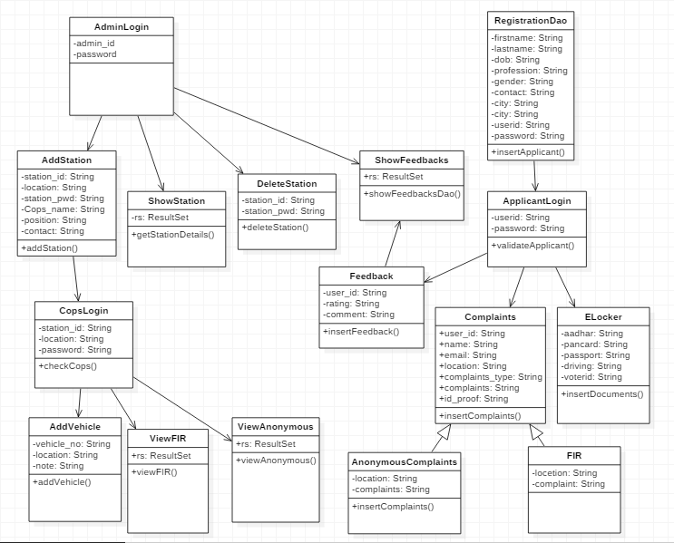

Fig 9: Class Diagram for **Citi-Cops**

**4.3 State Diagram:**

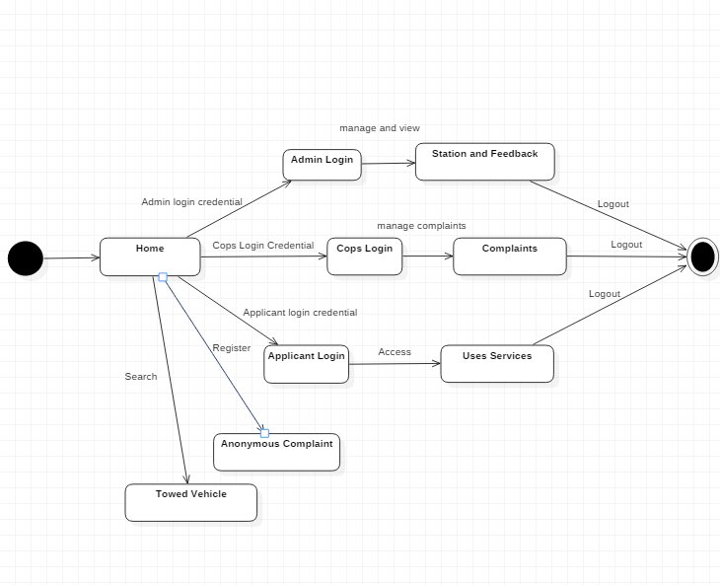

Figure 10: State Diagram for **Citi-Cops**

**4.4 Database Schema**

**Entity & Attribute Identification, Description & Justification:**

From the study of Citi-Cops, we have identified following entity types:

* **Complaints**
* **ELocker**
* **Anonymous_Complaint**
* **Registration**
* **Feedback**
* **SOS**
* **Station_info**
* **Vehicle**

**List of Tables**

**Complaints:-**

**Description: -** Detail related to complaint which is filed by Applicant and managed and seen by Cops and Station Head.

**Entity Name: COMPLAINTS**

**Type:** Strong Entity

**Attribute Description: -**

Table 1: Complaints table

|  |  |  |  |
| --- | --- | --- | --- |
| **Attribute** | **Domain** | **Description** | **Null?** |
| **User_id** | **varchar(30)** | **Primary Key** | **Not Null** |
| **Username** | **varchar(20)** |  | **Not Null** |
| **Email** | **varchar(50)** |  | **Not Null** |
| **Location** | **varchar(20)** |  | **Not Null** |
| **Complaint_type** | **varchar(20)** |  | **Not Null** |
| **Complaint_id** | **Int(10)** | **Auto Inc.(Sequence)** | **Not Null** |
| **Complaint** | **varchar(1500)** |  | **Not Null** |
| **idproof** | **varchar(80)** | **Image file** | **Not Null** |
| **status** | **varchar(6)** | **Seen or unseen** | **Not Null** |

**ELocker:-**

**Description: -** Detail related to E-Locker which is uploaded and submitted by Applicant.

**Entity Name: ELocker**

**Attribute Description**

Table 2: ELocker table

|  |  |  |  |
| --- | --- | --- | --- |
| **Attribute** | **Domain** | **Description** | **Null?** |
| **User_id** | **Varchar(30)** | **Primary Key** | **Not Null** |
| **Aadhar** | **Varchar(80)** | **Image file** | **Not Null** |
| **License** | **Varchar(80)** | **Image file** | **Not Null** |
| **Pancard** | **Varchar(80)** | **Image file** | **Not Null** |
| **Voterid** | **Varchar(80)** | **Image file** | **Not Null** |
| **Passport** | **Varchar(80)** | **Image file** | **Not Null** |

**Anonymous Complaints:-**

**Description: -** Detail related to anonymous complaint which is filed and submitted by Applicant and managed and functioned by Cops or Station Head.

**Entity Name: Anonymous Complaints**

**Attribute Description**

Table 3: Anonymous Complaints table

|  |  |  |  |
| --- | --- | --- | --- |
| **Attribute** | **Domain** | **Description** | **Null?** |
| **Location** | **Varchar(20)** | **Station location** | **Not Null** |
| **Complaints** | **Varchar(1300)** | **Complaint detail** | **Not Null** |
| **Complaint_date** | **Date** | **Filing Date** | **Not Null** |

**Feedback:-**

**Description: -** Details related to Feedback which is submitted by Applicant and managed and seen by Admin Only.

**Entity Name: Feedback**

**Attribute Description**

Table 4: Feedback table

|  |  |  |  |
| --- | --- | --- | --- |
| **Attribute** | **Domain** | **Description** | **Null?** |
| **User_id** | **Varchar(20)** | **Primary Key** | **Not Null** |
| **Rating** | **Int(1)** | **Website rating** | **Not Null** |
| **Comment** | **Varchar(200)** | **Feedback Details** | **Not Null** |

**Registration: -**

**Description: -** Details related to Applicant Registration, all necessary details related to Applicant personal details and further details.

**Entity Name: Registration**

**Attribute Description**

Table 5: Registration table

|  |  |  |  |
| --- | --- | --- | --- |
| **Attribute** | **Domain** | **Description** | **Null?** |
| **Fname** | **Varchar(20)** | **First name** | **Not Null** |
| **Lname** | **Varchar(20)** | **Last Name** | **Not Null** |
| **DOB** | **Date** | **Date of Birth** | **Not Null** |
| **Profession** | **Varchar(15)** |  | **Not Null** |
| **Gender** | **Varchar(6)** |  | **Not Null** |
| **Contact** | **Varchar(10)** |  | **Not Null** |
| **City** | **Varchar(20)** |  | **Not Null** |
| **Email_id** | **Varchar(30)** |  | **Not Null** |
| **User_id** | **Varchar(30)** | **Primary Key** | **Not Null** |
| **Password** | **Varchar(16)** |  | **Not Null** |

**Station Info: -**

**Description: -** Details related to Station and It’s Credentials which is provide by Admin to every Station of the city.

**Entity Name: Station info**

**Type:** Strong Entity.

**Attribute Description**

Table 6: Station info table

|  |  |  |  |
| --- | --- | --- | --- |
| **Attribute** | **Domain** | **Description** | **Null?** |
| **Station_id** | **Varchar(10)** | **Primary key** | **Not Null** |
| **Location** | **Varchar(20)** |  | **Not Null** |
| **Station_Password** | **Varchar(20)** |  | **Not Null** |
| **Station_Head** | **Varchar(20)** |  | **Not Null** |
| **Position** | **Varchar(20)** |  | **Not Null** |
| **Contact** | **Varchar(10)** |  | **Not Null** |

**SOS: -**

**Description: -** Details related to Applicant’s SoS complete information, applicant’s nearby or closed one’s details regarding email, contact, name.

**Entity Name: SoS**.

**Attribute Description**

Table 7: SOS table

|  |  |  |  |
| --- | --- | --- | --- |
| **Attribute** | **Domain** | **Description** | **Null?** |
| **User_id** | **Varchar(30)** |  | **Not Null** |
| **Person1_name** | **Varchar(20)** |  | **Not Null** |
| **Person1_contact** | **Varchar(10)** |  | **Not Null** |
| **Person1_email** | **Varchar(30)** |  | **Not Null** |
| **Person2_name** | **Varchar(20)** |  | **Not Null** |
| **Person2_contact** | **Varchar(10)** |  | **Not Null** |
| **Person2_email** | **Varchar(30)** |  | **Not Null** |
| **Person3_name** | **Varchar(20)** |  | **Not Null** |
| **Person3_contact** | **Varchar(10)** |  | **Not Null** |
| **Person3_email** | **Varchar(30)** |  | **Not Null** |
| **Person4_name** | **Varchar(20)** |  | **Not Null** |
| **Person4_contact** | **Varchar(10)** |  | **Not Null** |
| **Person4_email** | **Varchar(30)** |  | **Not Null** |

**Vehicle:-**

**Description: -** Details related to Towed Vehicle their location of towed station and a Remark and note for further queries and information.

**Entity Name: Vehicle**

**Attribute Description**

Table 8: Vehicle table

|  |  |  |  |
| --- | --- | --- | --- |
| **Attribute** | **Domain** | **Description** | **Null?** |
| **Vehicle_no** | **Varchar(10)** | **Primary Key** | **Not Null** |
| **Location** | **Varchar(20)** | **Station location** | **Not Null** |
| **Note** | **Varchar(20)** | **Remarks/note** | **Not Null** |

**Chapter – 5**

**Project development methodology**

**SDLC:**

**Introduction:**

Software Development Life Cycle, SDLC for short, is a well-defined, structured sequence of stages in software engineering to develop the intended software product.

Incremental Model is a process of software development where requirements are broken down into multiple standalone modules of software development cycle. Each iteration passes through the **requirements, design, coding and testing phases**. And each subsequent release of the system adds function to the previous release until all designed functionality has been implemented.

The system is put into production when the first increment is delivered. The first increment is often a core product where the basic requirements are addressed, and supplementary features are added in the next increments. Once the core product is analysed by the client, there is plan development for the next increment.

**Advantages of SDLC Model**

* Generates working software quickly and early during the software life cycle.
* This model is more flexible – less costly to change scope and requirements.
* It is easier to test and debug during a smaller iteration.
* In this model customer can respond to each built.
* Easier to manage risk because risky pieces are identified and handled during it’d iteration.

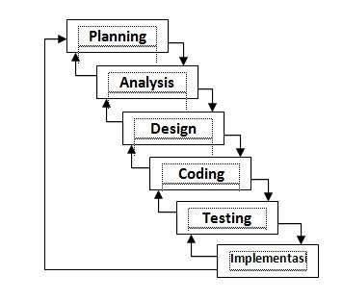

**Introduction:**

The design and implementation of this project will be carried out in a completely step-by-step manner. Because project is unique undertakings, they involve a degree of uncertainty. Organization performing projects will usually divide each project into several project phases to provide deter management organization. Collectively, the project life cycle serves to define the beginning and the end of a project the entire project is divided in the following phases.

**Phase 1- Study and Analysis phase**

In this phase, the data, facts and figures gathered by knowing problem of different user. The problems in the current system will be identified and necessary improvements will be recommended. Thus a new system, as a solution will be proposed. The emphasis is on the way of information retrieval. The new system should provide, the required frequency and accuracy of and result.

**Phase 2- Design phase**

The design of a system produces the details that state how a system will meet the Requirement identified during system analysis. In this phase, the detailed specifications for the new system will be formulated. They will describe its feature- the outputs, inputs, files and database and procedures- all in a manner that meets project requirement.

After the E-R we prepared all the tables and procedure in computer storage with the help of MySQL database management system this is also called a relational database.

**Phase 3- Coding and Implementation Phase**

The activity following logical design, which produces program software, files and working system, will be carried out. This process will be initiated by identifying the key factors responsible for the layout for the layout of the software. The many suggestions received at previous stage are analysed and categorized. Then the solutions of these problems will be designed and developed. In coding phase we implemented the logics from which we can access the database and can solve and problem. The physical model will cover all the physical the organization issues leading to the accrual relation that will be implemented on the system. In this phase we made a user friendly interface through which we can interact with the system.

**Phase 4- Testing Phase**

Testing is the process of executing with explicit intention of finding error that is, making the functioning fall. In this process, the close examination of procedural details will be done. During this phase, the input, the output and external data will be tested. It checks weather the input data is correct and that the desired output is obtained or not. The entire step above will lead to an application that will suitable demonstrate the objectives already described. In the phase we will perform certain operation on each module by using the real data and observe the how much it is accurate. After finding some error we will again modify the system and again test it.

**Summary:**

It explains System Development Life Cycle as the Chosen Project Development Methodology.

**Chapter – 6**

**SYSTEM IMPLEMENTATION**

**6.1 Introduction:**

System Implementation is a process of implementing the idea that we analyze for the system. The system we proposed needs a technology through which we can design and develop it. For this we used JSP TECHNOLOGY of JAVA programming and SQLYOG for database.

JAVA as the programming language: There are a number of different reasons for which we have chosen JAVA as the programming language for our project.

* Java is powered by Oracle - one of the leaders in the industry. Java also gets enormous support from big technology companies like IBM, Google, Red hat, so it has been always evolving over the years.
* There are a lot of open source libraries which you can choose for building your applications.
* There are many superior tools and IDEs that makes your Java development easier.
* There are many frameworks that help you build highly reliable applications quickly.
* The community around Java technology is very big and mature, so that you can get support easily.
* Java encourages error-free programming by being strictly typed and performing run-time checks.
* Java programs carry with them substantial amounts of run-time type information that is used to verify and resolve accesses to objects at run time.
* Java is a robust, reliable, portable has built in exception handling and is much more standardized and has a much richer collection of core functions than any other general-purpose computer language.
* The core Java API is rich and includes standard packages for serial I/O , Ethernet and internet access , security, graphics, sound, and other typical functions.
* Java code can be checked, tested and debugged on a platform such as a PC, then moved with little or no changes to an embedded system.

**6.2 MYSQL as database:**

There are many reasons for choosing MYSQL as the database.

**Data Security:** MySQL is globally renowned for being the most secure and reliable database management system used in popular web applications like Word Press, Drupal, Joomla, Facebook and Twitter. The data security and support for transactional processing that accompany the recent version of MySQL, can greatly benefit any business especially if it is an ecommerce business that involves frequent money transfers.

**Scalability and High Performance:** MySQL offers unmatched scalability to facilitate the management of deeply embedded apps using a smaller footprint even in massive warehouses that stack terabytes of data. On-demand flexibility is the star feature of MySQL. This open source solution allows complete customization to ecommerce businesses with unique database server requirements.

MySQL features a distinct storage-engine framework that facilitates system administrators to configure the MySQL database server for a flawless performance. Whether it is an ecommerce website that receives a million queries every single day or a high-speed transactional processing system, MySQL is designed to meet even the most demanding applications while ensuring optimum speed, full-text indexes and unique memory caches for enhanced performance.

**High Availability:** With its distributed, shared-nothing architecture, MySQL Cluster has been carefully designed to deliver 99.999% availability ensuring resilience to failures and the ability to perform scheduled maintenance without downtime.

**6.3 Architecture Used:**

**Client Server Architecture:**

Client/server architecture works when the client computer sends a resource or process request to the server over the network connection, which is then processed and delivered to the client. A server computer can manage several clients simultaneously, whereas one client can be connected to several servers at a time, each providing a different set of services. In its simplest form, the Internet is also based on client/server architecture where the Web server serves many simultaneous users with Web page and or website data.

**Advantages:**

* Unlike P2P, where there is no central administration, here in this architecture there is a centralized control. Servers help in administering the whole set-up. Access rights and resource allocation is done by Servers**.**
* All the files are stored at the same place. In this way, management of files becomes easy. Also it becomes easier to find files. As all the data is stored on server it’s easy to make a back-up of it. Also, in case of some break-down if data is lost, it can be recovered easily and efficiently. While in peer computing we have to take back-up at every workstation.
* Changes can be made easily by just upgrading the server. Also new resources and systems can be added by making necessary changes in server.
* As new information is uploaded in database, each workstation need not have its own storage capacities increased (as may be the case in peer-to-peer systems). All the changes are made only in central computer on which server database exists.  
  Rules defining security and access rights can be defined at the time of set-up of server.

**6.4 MVC Architecture:**

MVC is popular as it isolates the application logic from the user interface layer and supports separation of concerns. Here the Controller receives all requests for the application and then works with the Model to prepare any data needed by the View. The View then uses the data prepared by the Controller to generate a final presentable response. The MVC abstraction can be graphically represented as follows.

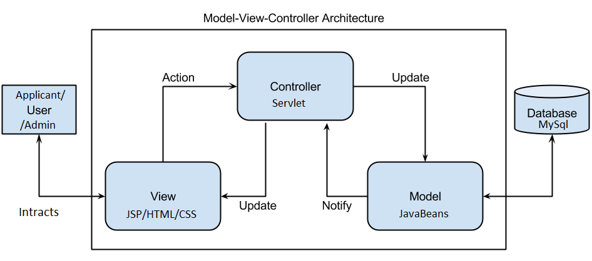

**Figure: MVC Architecture**

**CHAPTER-7**

**SYSTEM TESTING**

**7.1 Introduction:**

Software testing is an integral part of the software development life cycle (SDLC). Effectively and efficiently testing a piece of code is equally important, if not more, than writing it. Software testing is nothing but subjecting a piece of code to both, controlled as well as uncontrolled operating conditions, is an attempt to observe the output and examine whether it is in accordance with certain pre-specified condition.

**7.2 Brief Description:**

Citi-Cops software is a form of online complaint registration application which allows people to register the crime information or complaint or their queries related to vehicle or feedback about their throughout experience of the site. This document gives the detailed description of the functional and non-functional requirement of the client. Once the complaint is registered or the services of E-Locker and SOS are registered the output and view module and actions on the complaints can’t be delayed in any circumstances. Now, the citizens will have access to Station head through the web using Contact to Cops module.

**Citi-Cops** introduced transparency and accountability in the whole system. The Technological benefits of Citi-Cops are to maintain information, monitor and enhance the performance of the police department, to take a critical look at the existing system, processes and the processes of the department so as to identify and remove the redundancy.

* Improve efficiency and effectiveness and more flexibility and ease in Police department.
* Availability of online complaints ,online E-Locker and SOS and Contact to Cops services which will lead to better ,detailed safer and assured actions towards the problems of citizens to the Police.
* Availability of Towed Vehicle with its Station location along with the Station heads Contact, to reach out at right place we provided Map Location.
* Better Administration and better decision making through the information of crime rates.

**7.3 Test Approach:**

Software testing is an investigation conducted to provide stakeholders with information about the quality of the project or services under test. Software testing can also provide an objective, independent view of the software to allow the business to appreciate and understand the risks of software implementation. Test techniques include, but are not limited to, the process of executing a program or application with the intent of finding software bugs.

**7.4 Test Case:**

The importance of software testing and its implication cannot be over emphasized. Software testing is a critical element of software quality assurance and represents the ultimate review or the specifications, design and coding.

|  |  |  |  |  |  |  |
| --- | --- | --- | --- | --- | --- | --- |
| **S.No** | **Test case name** | **Description** | **Input** | **Expected Result** | **Actual Result** | **Status** |
| 1 | **Admin**  **Login** | Verify that admin login with valid username/  password | Username and Password | On clicking the admin login button,  Admin Home page should appear | Admin Home Page Appears | Pass |
| 2 | **Registration** | Verify that Applicant registration with proper validation. | Applicant’s all relevant detail and info. | On clicking Submit button ,The Login page must appear | Applicant Login Page Appears | Pass |
| 3 | **Police/Cops Login** | Verify that Police login with Station_id / Station_Pwd | Station_id,Station Location and Station Password | On clicking the Login button, The Cops Account Page should appear. | Police/Cops Account Page Appears | Pass |
| 4 | **Change Password** | Verify that Changing password with | New Password | On clicking the change Password,  Password must be changed and reflects into database | Password Changed Successfully | Pass |
| 5 | **Forgot Password** | Verify that forgot password with Email-Services | Registered Email id and Password | On clicking the forgot Link, A mail will be sent to user with proper credentials | Email sent and Password Reassigned to the User_id | Pass |
| 6 | **Applicant/**  **User Login** | Verify that using USer_id and Password | Submitted Login Id /Password | On clicking the Login button ,The Home Page with all access must appear | Home Page with all access and services Appears | Pass |
| 7 | **File**  **Complaints** | Registering any type of complaint with all details | User_id from session and complaint details with proper validation | On clicking submit button ,Complaint will be filed with ID-Proof. | Complaint registered with valid ID Proof | Pass |
| 8 | **View Complaint** | Complaint History ,Details and status will be showed | Showing Complaint using Id | On Clicking Show Complaint ,The Complete information regarding complaint with current status will be showed and window must appear. | The Compliant Show Page /window appears with current status of Complaint. | Pass |
| 9 | **E-Locker and SOS** | User_id and all relevant information regarding the mentioned Services. | Click the E-Locker and SOS Link and submit details | On clicking the E-Locke and SOS link ,the Page should appear | Both Page appears and form submitted successfully | Pass |
| 10 | **Towed Vehicle and Contact to cops** | Verify Towed vehicle with Vehicle No. and Verify Contact to Cops with Station Location | Click the Towed vehicle and  Contact to cops link | On finding the vehicle no, The Complete information with station location must appear, On clicking the Station Location ,The Complete information of the station should appear | Towed vehicle information page appears,  Contact to Cops using searched location appears with MAP Location | Pass |
| 11 | **Logout** | User/Admin/  Cops will be successfully logged out of the system | Click the Logout Link | On clicking the Logout link ,the Session must expire and logged out | Session expires and User Logged out of the Page | Pass |

**7.5 Testing Objective:**

The main objective of testing is to uncover a host of errors, systematically and with minimum effort and time. Starting formally we can say,

* Testing is a process of executing a program with the intent of finding an arror.
* A successful test is one that uncovers an as yet undiscovered error.
* A good test case is one that has a high probability of finding an error, if it exists.

But there is one thing that testing cannot do (just to quote a very famous sentence) “Testing cannot show the absence of defects, it can only show that software defects are presents”.

As the test result are gathered and evaluated they begin to a qualitative indication of the reliability of the application. If server errors are detected, the overall quality of the software is a natural suspect. If, on the other hand, all the errors, which are encountered, are easily modifiable, then one of the two conclusions can be made:

* The tests are inadequate to detect possibly errors.
* The software more or less confirm to the quality and reliable standard.

**Chapter-8**

**PROJECT FEATURES**

**8.1 PROJECT MODULES:**

To develop this project we require Applicant, Cops and the administrator. So we have three modules.

1. **Applicant**
2. **Cops**
3. **Admin**

**8.1.1 Applicant:**

* The Applicant can register the Complaints irrespective of its type whether it is FIR, Public or Anonymous Complaint and the applicant can also view their complaints with all the filled information.
* The Applicant can also view the current status of the complaint whether it’s seen or unseen.
* The Applicant can use the service of E-Locker, SOS and filing complaint once he/she has logged in successfully.
* The Applicant can search their Towed Vehicle’s information including its Towed Station with MAP Location and can also contact the Station Head for the confirmation.
* The Applicant can also submit the Feedback and gives rating as per his/her experience of the Citi-Cops site.

**8.1.2 Police/Cops:**

* The Cops/Police can see and take actions to the complaints filed by any applicant and also confirm the status with seen/unseen which will be sent to the applicant for the convenient.
* The Cops/Police adds the vehicle which has been towed or created trouble on the Vehicle Trouble Dashboard which later on viewed by the Users or Vehicle owner.
* The Cops/Police can also differentiate the complaint type and act based on the type like FIR, Public Complaints, and Anonymous Complaints etc.
* The Station ID, Station Password along with the Station Location is provided to each Station Head for accessing the Citi-Cops application and act as per the situation and needs.
* The Cops/Police can only see, view and take actions for their respective Location’s complaints.

**8.1.3 Admin:**

* The Most Important role of the Admin is to provide credentials to each Station and their Station Head so that one can access the services of the Citi-Cops application.
* The Admin views the feedback given by the applicant or users and act accordingly and can also manage/delete the feedback.
* The Admin insert, delete and can also see the Station details and its credentials.

**Citi-Cops Home Page**

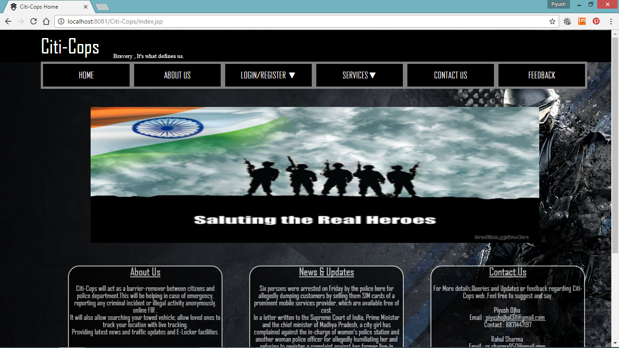

**Citi-Cops About Us Page**

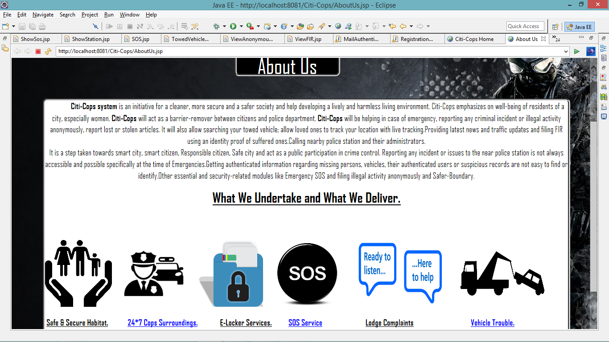

**Citi-Cops Registration Page**

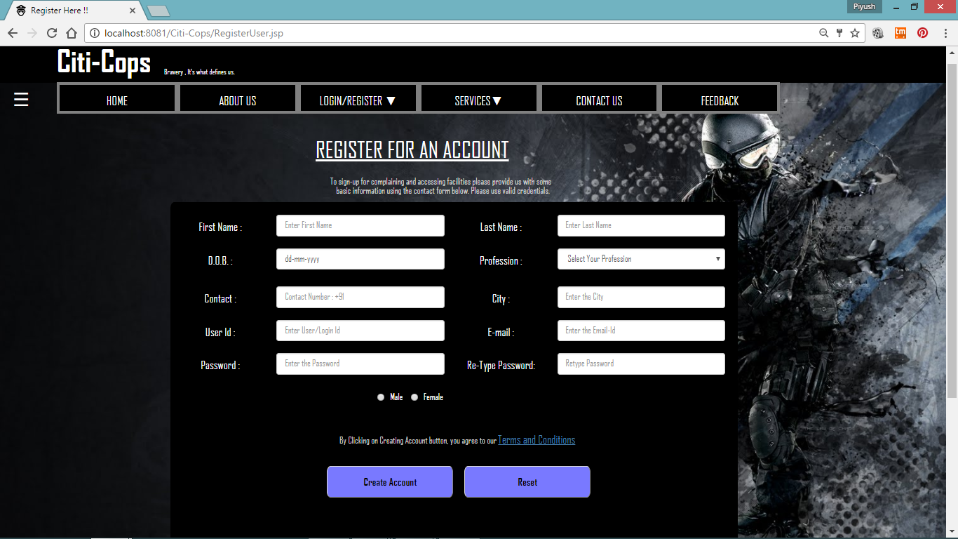 **Citi-Cops Applicant Login Page**

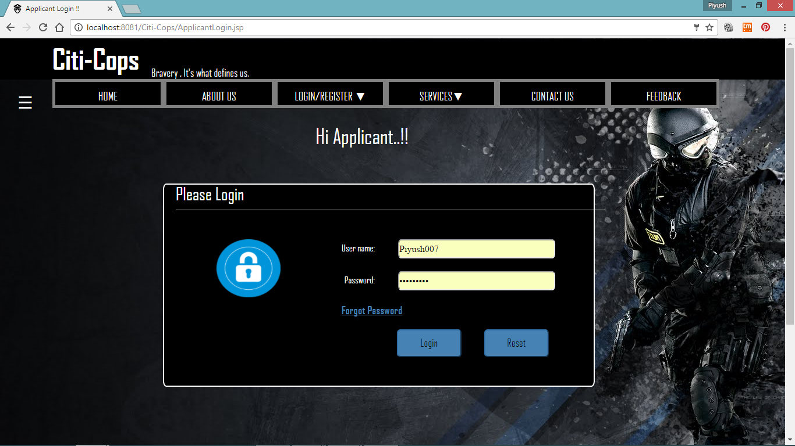 **Citi-Cops Cops Login Page**

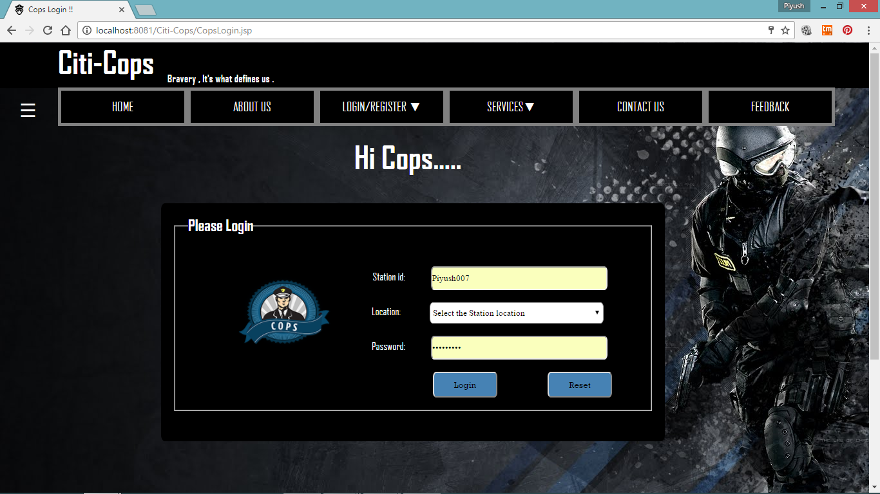

**Citi-Cops Admin Login Page**

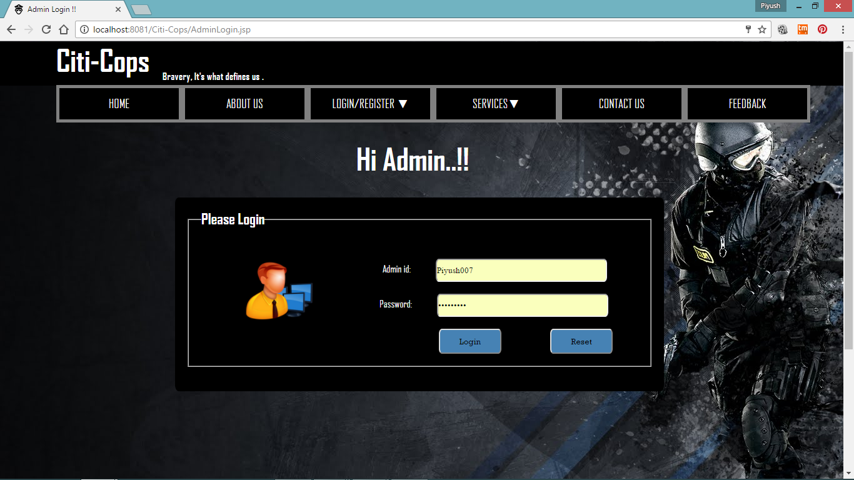

**Citi-Cops FIR/Public Complaint Page**

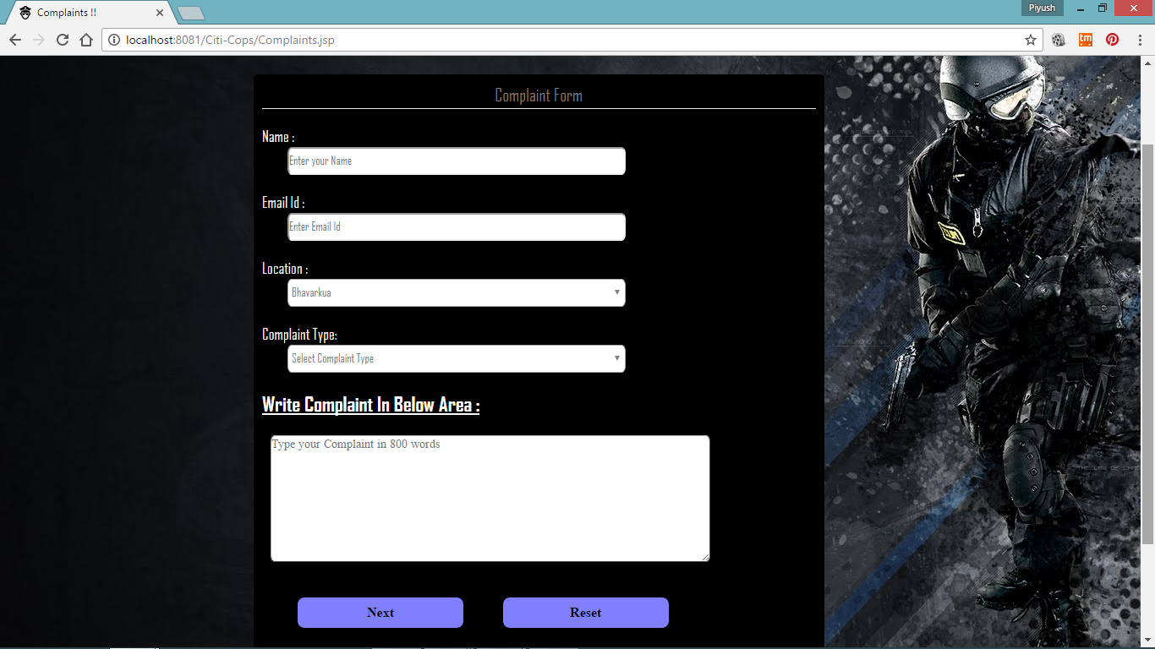

**Citi-Cops Vehicle Trouble Page**

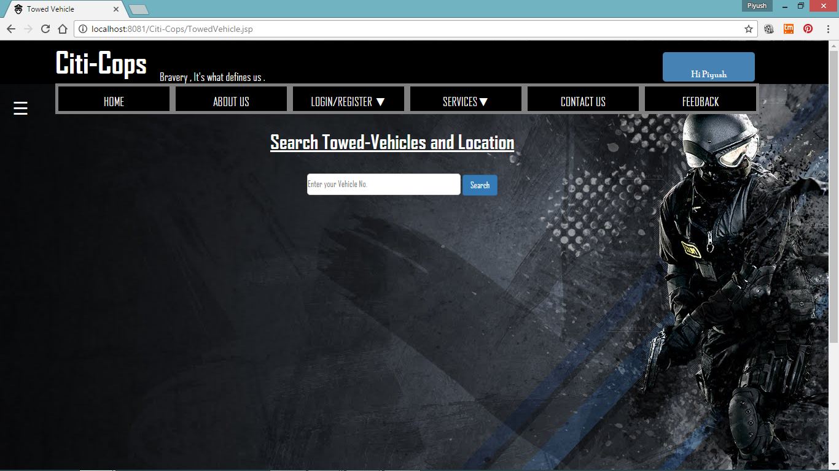

**Citi-Cops E-Locker Page**

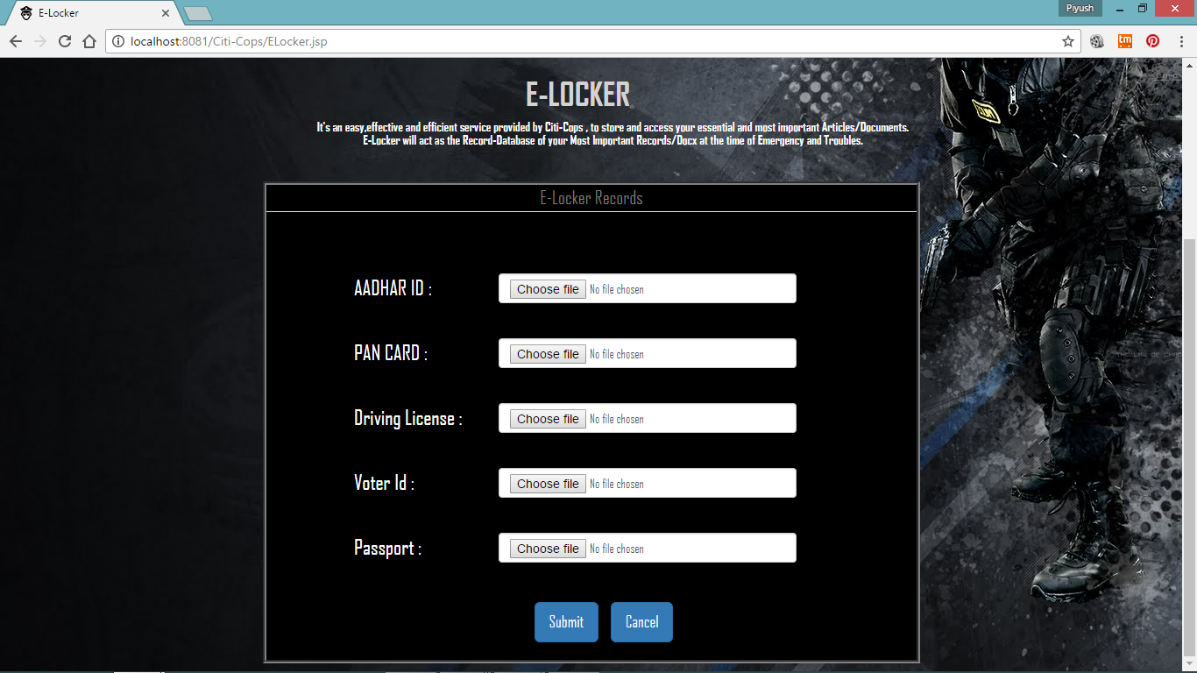

**Citi-Cops Contact to Cops page**

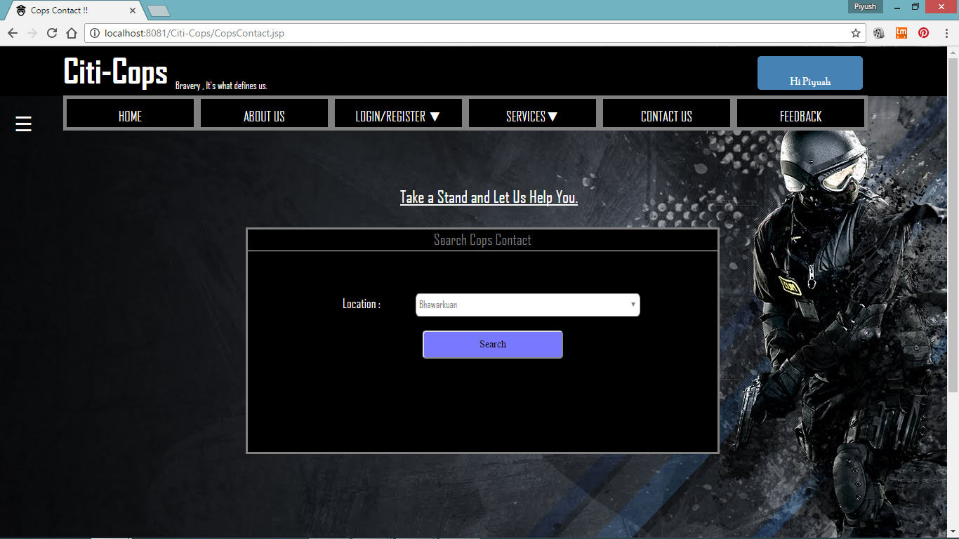

**Citi-Cops Feedback-Form page**

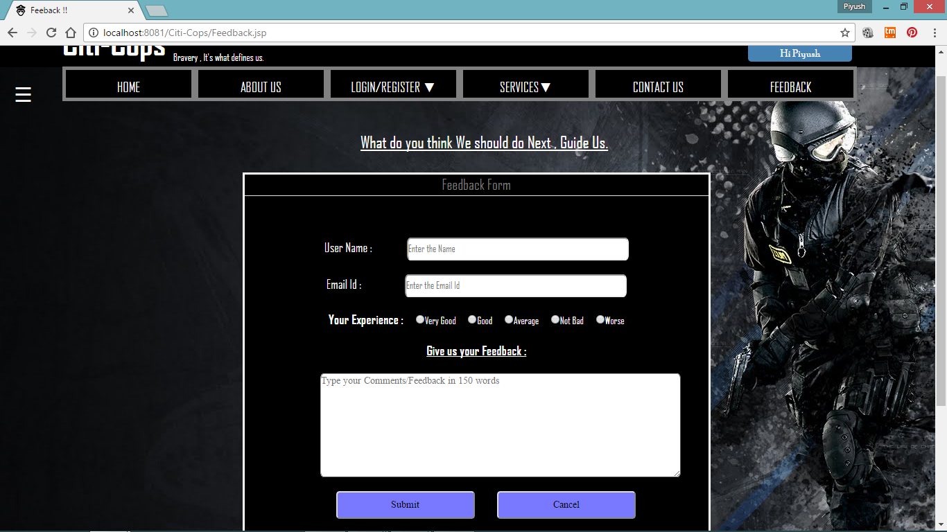

**Citi-Cops COPS HOME page**

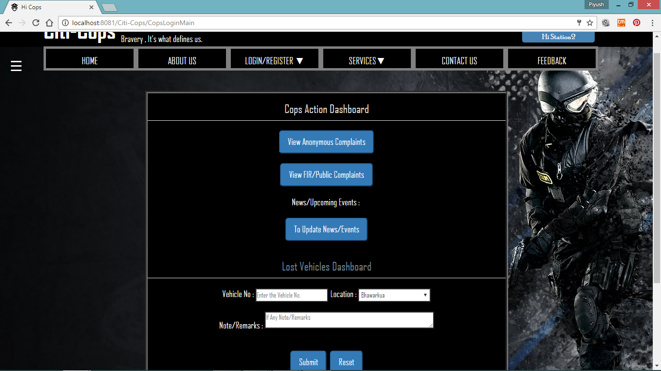

**Citi-Cops Admin Home page**

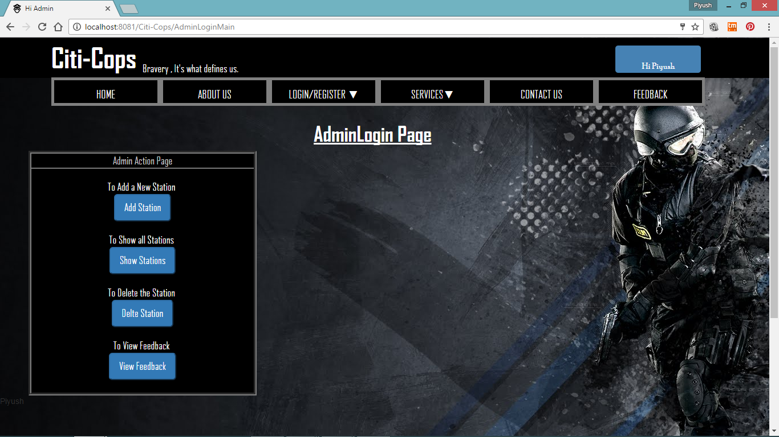

**Citi-Cops Anonymous Complaint page**

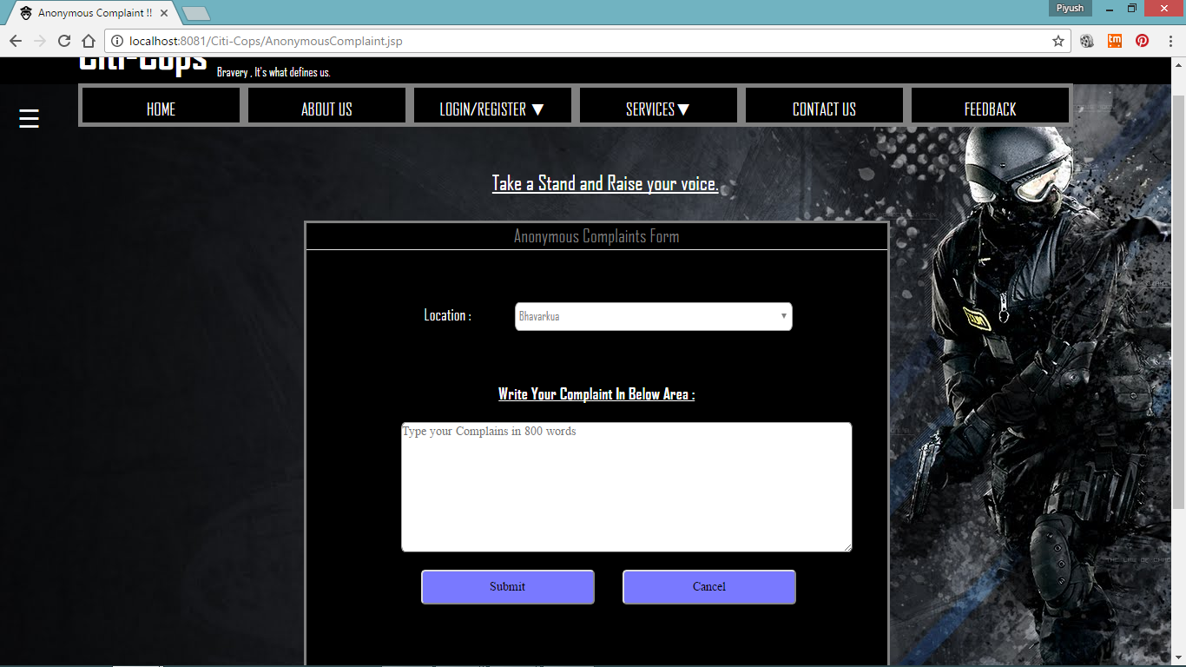

**Citi-Cops Anonymous Complaint Dashboard page**

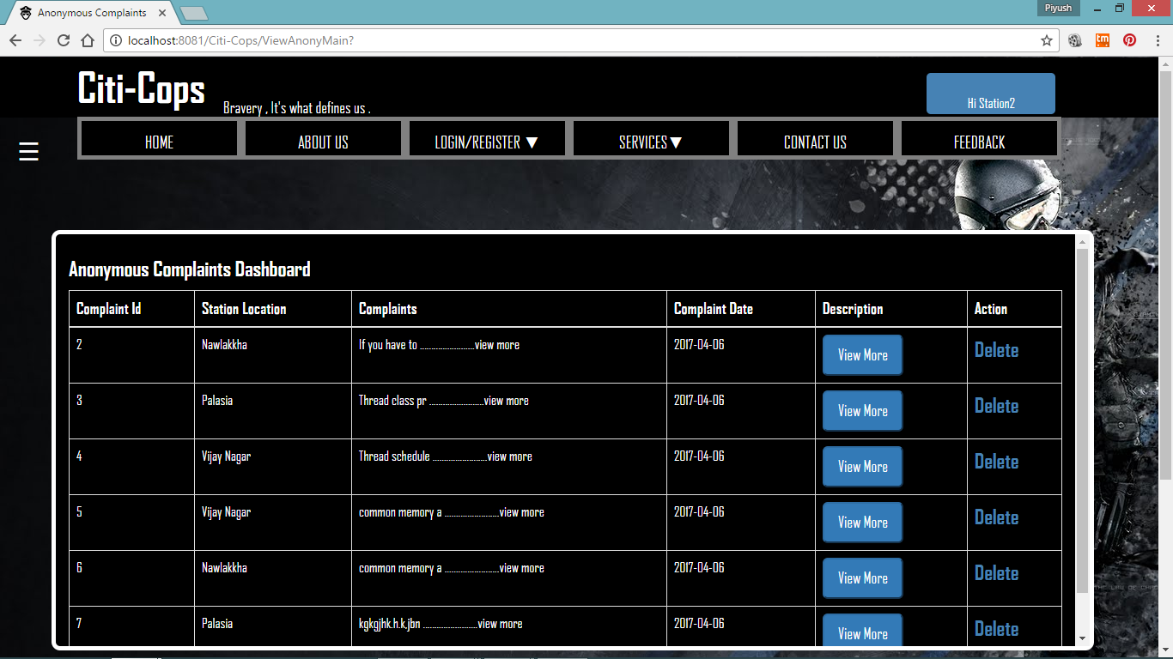

**Citi-Cops FIR/Public Complaint Dashboard page**

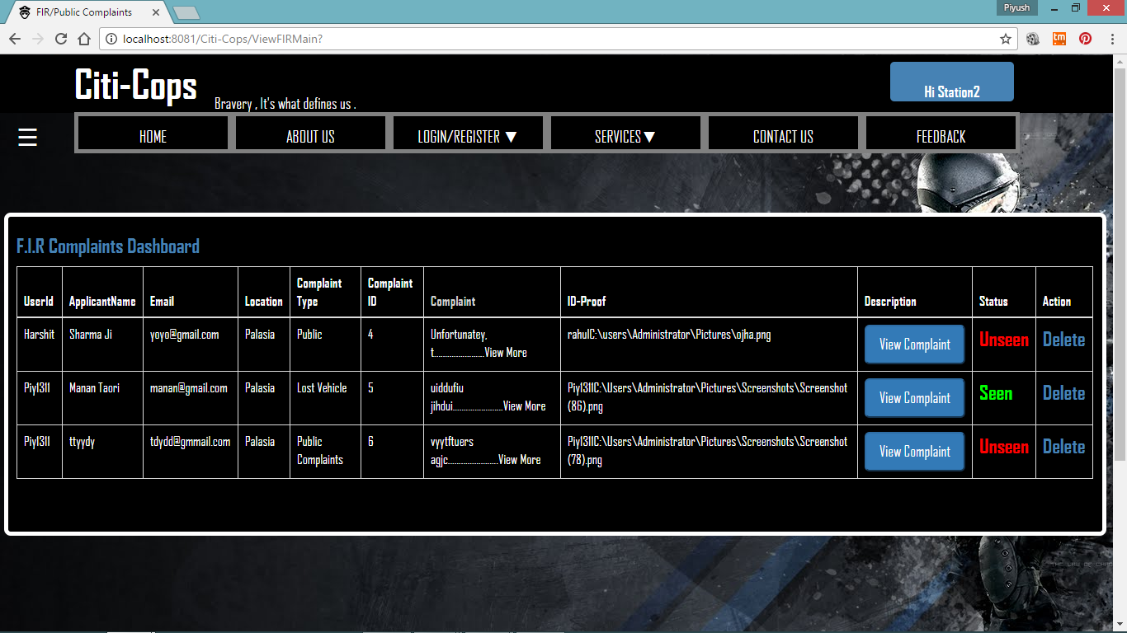

**Citi-Cops Feedback Dashboard page**

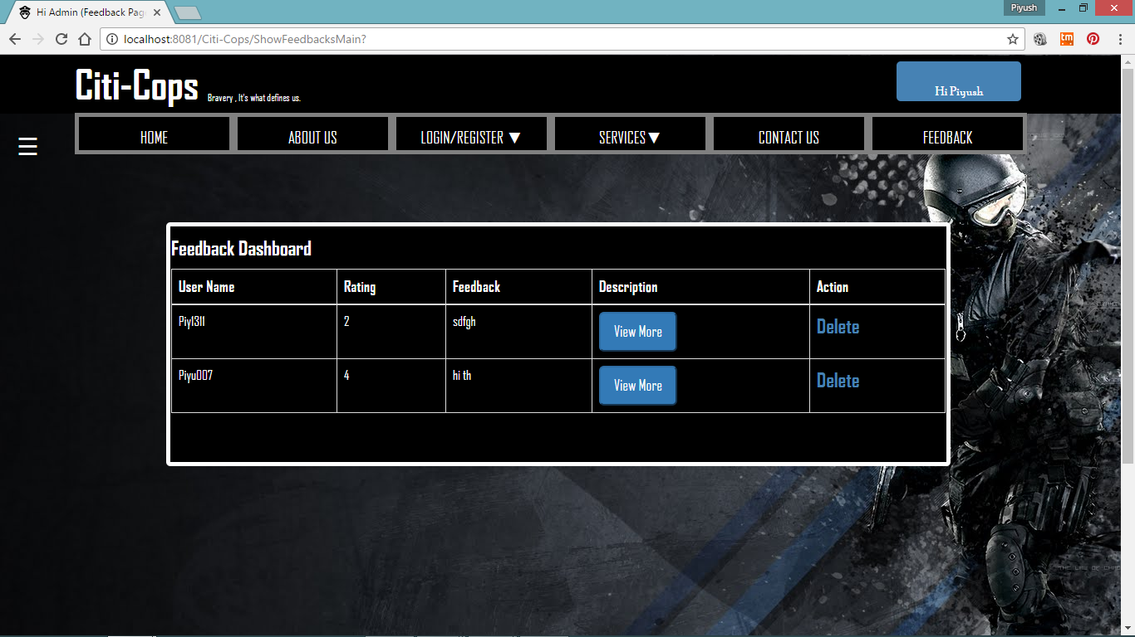

**Chapter - 9**

**Limitations**

The **Project** although fulfils all his objectives and scenario and has reached its aims, there are some limitations of the project which can be accomplished and effectuate in the future and can also be reshaped and reoriented with complete ease and effectiveness.

Some of the limitations which we encountered and came into contact with are:

* The Map Location of the all the Stations in future will be attained in the comprehensive dynamic manner.
* The application might straggle or might lose its strength in the multithreading or highly-threaded environment.
* The Actions on the complaints and other queries are taken by the Cops only and They can view the complaint and change the status unseen to seen but the Actions on the complaint is up to the Police Department, There is an absence of the module which can influence or team them to take action and give updates to the applicant.
* The recent news and upcoming events or current updates from Cops can be in the futuristic approach of Citi-Cops.

**Chapter - 10**

**Conclusion**

The Technological benefits of Citi-Cops are to maintain information, monitor and enhance the performance of the department, to take a critical look at the existing system, processes and procedures of the Police department so as to identify and remove the redundancy.

The motive and objective behind embracing this as our project application is to make society safer, more secure and assuring the great future to our descendants, Since our nation is so close to be digitalized in coming years, **Citi-Cops** helps to digitalize our Police department completely .All these factors have contributed to a higher morale of the police officials at all the levels in police department as well. This project might result in great improvement in the organization’s functioning by reducing the effort spent by the general people.

* Duplication of work is avoided.
* Paper work is drastically diminished.
* Fetching and access of complete details of data is trouble-free.
* Better administration and co-ordination which leads to the improvement in efficiency in police department.
* Most essential it spreads awareness of rights and duties to the Society which hopefully leads to the better future and better nation.

**Bibliography**

The completion of this Project would not be possibly done without getting recommendation and consultation from some Books and Websites and some Tutorials. These sites, tutorials made that easy for us to get through with the troublesome occurred while developing the Project.

Some of the companions which made it possible to achieve the predetermined goals are as follows:

**Books:**

* “**Software Engineering**” by Dr. Ugrasen Suman.
* Microsoft Visio and UML tools.

**Tutorial Websites:**

* **Indebted specifically to :**[**http://stackoverflow.com/**](http://stackoverflow.com/)
* Java Tutorial at : [**http://www.javatpoint.com**](http://www.javatpoint.com)**.**
* Html, CSS, Bootstrap and JavaScript Tutorial at : [**https://www.w3schools.com**](https://www.w3schools.com)**.**
* Further Important Details at : [**https://www.codeproject.com**](https://www.codeproject.com)**.**